1. Drive motor
   1. Nominal input (no load): 12V, 0.167±0.001A
   2. Nominal output: 185 rpm (no load)
   3. Internal resistance: 3.5±0.5Ω -> theoretical stall current: 3-4A
   4. 0.15A & 68% nominal speed at 8.1V (no load)
   5. Speed loss at normal maximum torque: <≈3%  
      (at 69% nominal speed: 3%.)
   6. Encoder characteristics:
      1. **From Encoder.h library’s measurements:**
         1. **48 ticks per real rotation**
         2. **48 * 27 = 1296 ticks per apparent rotation**
      2. From oscilloscope
         1. 12 square wave periods per real (i.e. encoder wheel) rotation, 12*27=324 periods per apparent (i.e. shaft) rotation
         2. 1000±10 kHz output at nominal speed (no load).
2. Battery
   1. Voltage out: 6.4-8.4 V (do NOT exceed the voltage limit in charging or using.)
   2. Charging: Follow the steps below, IN SEQUENCE. You may have to wait a few seconds for the lights to change.  
      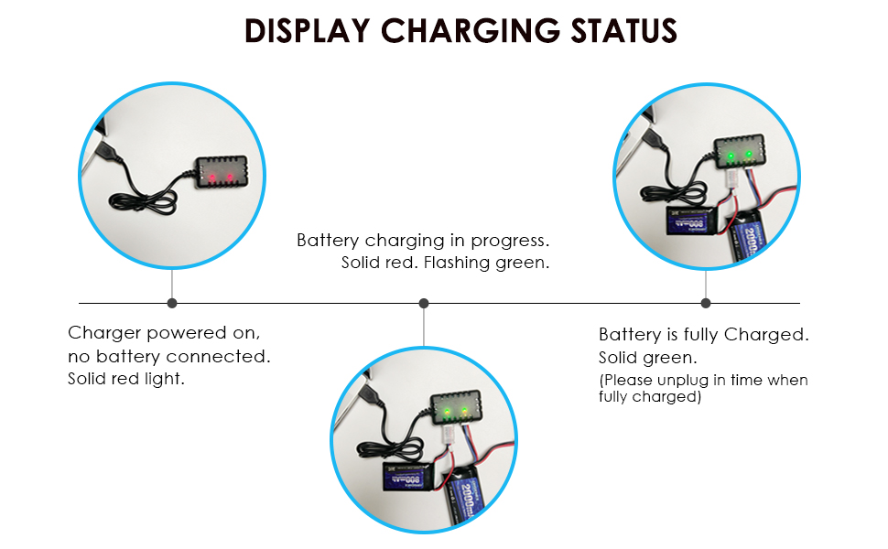
3. Ultrasonic
   1. Docs: [m5-docs (m5stack.com)](https://docs.m5stack.com/en/unit/sonic.i2c)
   2. Test code: [M5Unit-Sonic/Unit_SonicI2C_M5Core2.ino at master · m5stack/M5Unit-Sonic (github.com)](https://github.com/m5stack/M5Unit-Sonic/blob/master/examples/Unit_SonicI2C_M5Core2/Unit_SonicI2C_M5Core2.ino)
   3. I2C address: 0x57